**DAILY ONLINE ACTIVITIES SUMMARY**

|  |  |  |  |  |  |  |  |  |
| --- | --- | --- | --- | --- | --- | --- | --- | --- |
| **Date:** | **22-06-2020** | | | | | **Name:** | **Anix Jugal D’Cunha** | |
| **Sem & Sec** | **8 sem , A sec** | | | | | **USN:** | **4AL16CS013** | |
| **Online Test Summary** | | | | | | | | |
| **Subject** | | **SMS** | | | | | | |
| **Max. Marks** | | **60** | | **Score** | | | **Email was not been sent by TechGig, Hence Marks is unknown** | |
| **Certification Course Summary** | | | | | | | | |
| **Course** | **Learn HTML - For Beginners** | | | | | | | |
| **Certificate Provider** | | | **Udemy** | | **Duration** | | | **2.5 hours** |
| **Coding Challenges** | | | | | | | | |
| **Problem Statement:** Python program to find size of image | | | | | | | | |
| **Status: Competed** | | | | | | | | |
| **Uploaded the report in Github** | | | | | **yes** | | | |
| **If yes Repository name** | | | | | **alvas-education-foundation/dcunhaanixjugal** | | | |
| **Uploaded the report in slack** | | | | | **yes** | | | |

Online Test Details: (Attach the snapshot and briefly write the report for the same)

Email was not been sent by TechGig, Hence Marks is unknown

Certification Course Details: (Attach the snapshot and briefly write the report for the same)

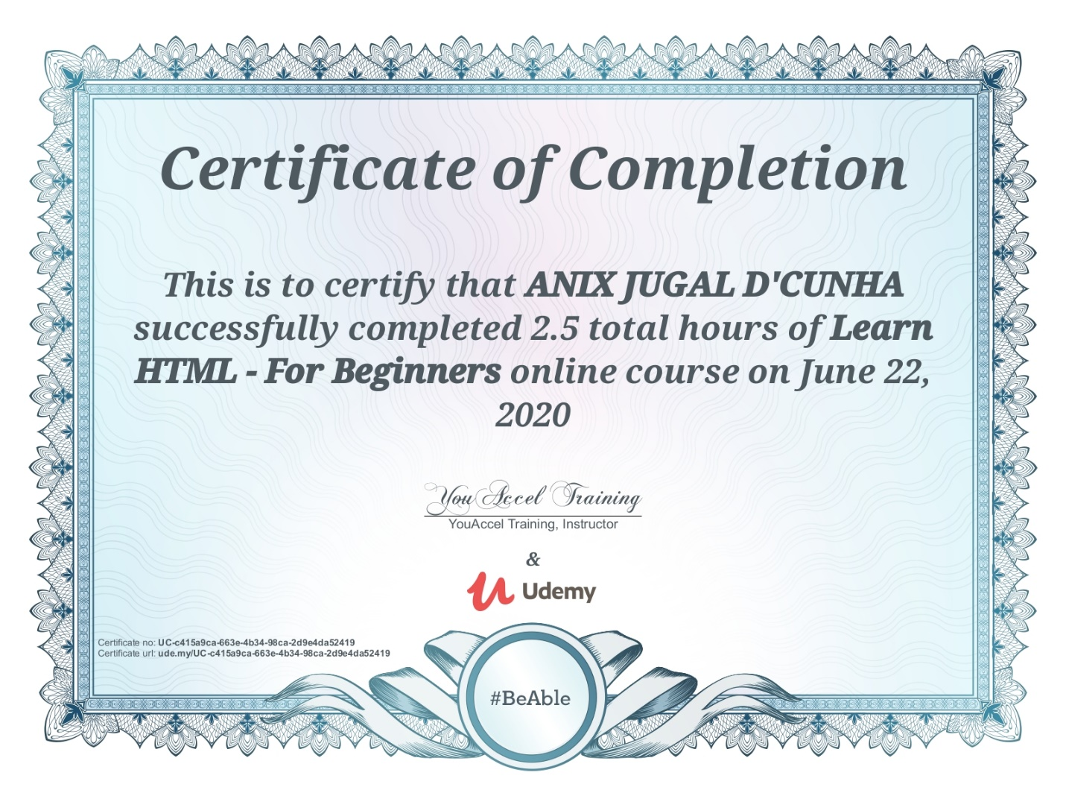

Coding Challenges Details: (Attach the snapshot and briefly write the report for the same)

Program->  python program to find size of image

def jpeg_res(filename):

""""This function prints the resolution of the jpeg image file passed into it"""

# open image for reading in binary mode

with open(filename,'rb') as img_file:

# height of image (in 2 bytes) is at 164th position

img_file.seek(163)

# read the 2 bytes

a = img_file.read(2)

# calculate height

height = (a[0] << 8) + a[1]

# next 2 bytes is width

a = img_file.read(2)

# calculate width

width = (a[0] << 8) + a[1]

print("The resolution of the image is",width,"x",height)

jpeg_res("img1.jpg")